Comparison of FOLH1 with Known Prostate Cancer Biomarkers (Primary Tumours)
To contextualize FOLH1 co-expression, a panel of known biomarkers and lineage-associated genes was selected. Several genes, including AR, PTEN, CDH1, and VIM, are biologically relevant to pancreatic cancer progression, while others such as KLK3, NKX3-1, TMPRSS2, and ERG are primarily prostate-associated and were included to compare FOLH1 with a prostate lineage signature. New biomarkers mentioned by Felecia during our meeting were also included and highlighted in the table below. They were all then compared with FOLH1 expression to check for expression patterns.
Each biomarker was then also used to split samples into low and high expression groups based on the median cut-off, and KM plots that produced a significant Hazard ratio are included below.

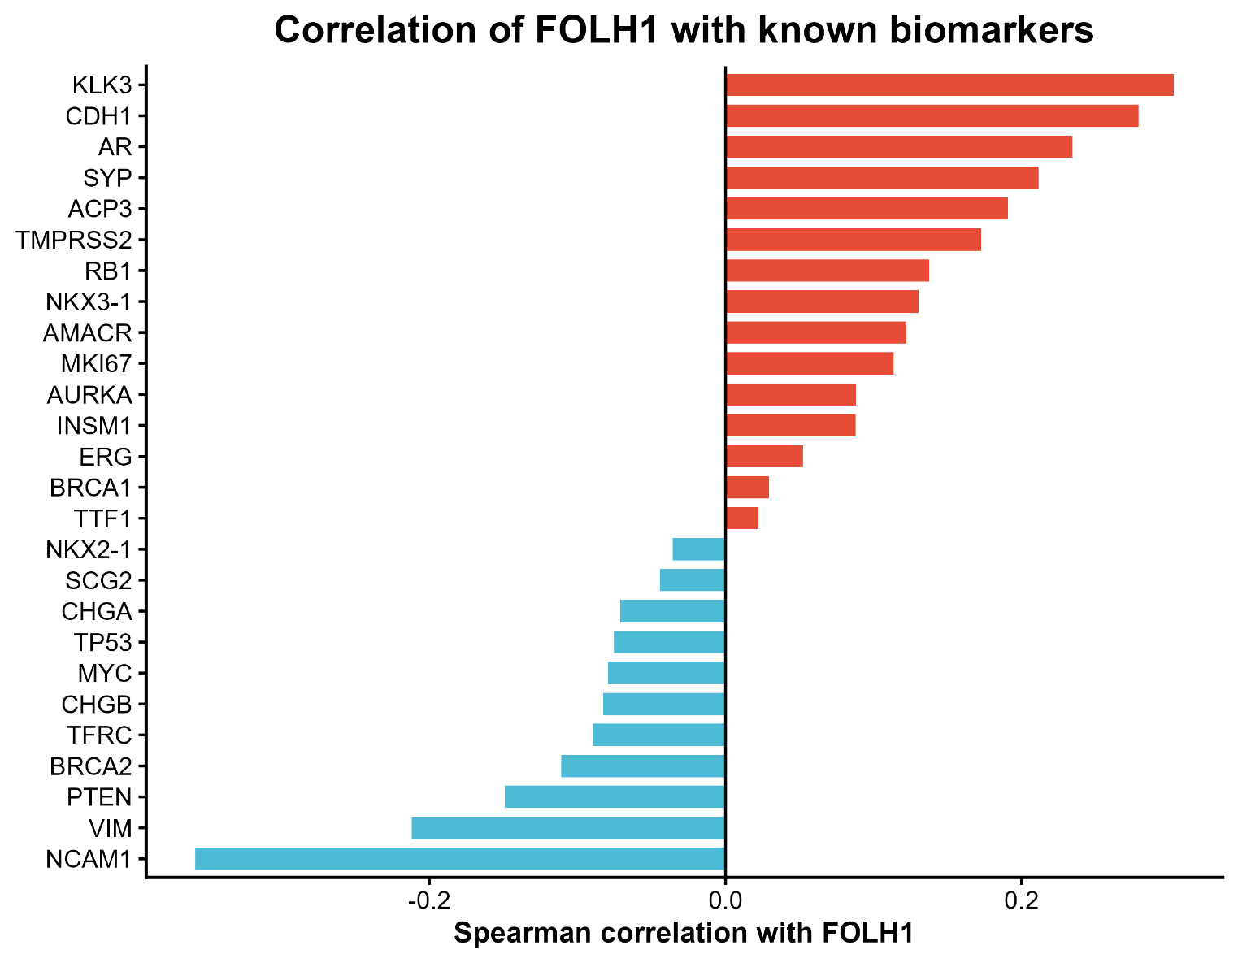
Biomarkers and their Spearman correlation summary
Gene | Protein biomarker | Rho | P Value | Relevance to Pca
KLK3 |  | 0.302852 | 3.78E-11 | Encodes PSA and is one of the best-known Pca biomarkers.
CDH1 |  | 0.279127 | 1.26E-09 | Epithelial adhesion gene; relevant to prostate cancer progression and epithelial phenotype
AR |  | 0.234392 | 4.03E-07 | Core androgen signalling gene; central to prostate cancer development, progression, and therapy response
SYP | Synaptophysin | 0.211446 | 5.13E-06 | Strong neuroendocrine marker in prostate cancer.
ACP3 | PAP | 0.190661 | 4.09E-05 | Classic prostate marker; less commonly used now than PSA but still relevant.
TMPRSS2 |  | 0.172814 | 0.000205 | Prostate-expressed gene; important in prostate cancer, especially through TMPRSS2-ERG fusion biology
RB1 |  | 0.13736 | 0.003258 | Tumour suppressor linked to aggressive and neuroendocrine-like prostate cancer
NKX3-1 |  | 0.130285 | 0.00528 | Prostate lineage transcription factor; commonly used as a prostate marker and associated with prostate differentiation
AMACR |  | 0.122251 | 0.008894 | Well-established prostate cancer biomarker, often overexpressed in prostate tumours
MKI67 |  | 0.113685 | 0.015034 | General proliferation marker used to assess tumour growth and aggressiveness
AURKA |  | 0.088152 | 0.059704 | Associated with advanced and castration-resistant prostate cancer, especially aggressive disease.
INSM1 |  | 0.087868 | 0.060533 | Marker of neuroendocrine differentiation, relevant in aggressive/neuroendocrine prostate cancer.
ERG |  | 0.052171 | 0.265716 | Important prostate cancer marker, especially in TMPRSS2-ERG fusion-positive tumours.
BRCA1 |  | 0.029467 | 0.529785 | DNA repair gene linked to inherited prostate cancer risk and more aggressive disease in some cases.
NKX2-1 |  | -0.03566 | 0.446938 | the gene behind TTF-1 protein marker; relevant mainly to neuroendocrine differentiation
SCG2 | Secretogranin II | -0.04446 | 0.342961 | Neuroendocrine-associated marker relevant to prostate cancer subtype switching.
CHGA | Chromogranin A | -0.07116 | 0.128788 | Marker of neuroendocrine differentiation in prostate cancer.
TP53 |  | -0.07543 | 0.107333 | Important tumour suppressor commonly altered in advanced prostate cancer
MYC |  | -0.07926 | 0.09056 | Oncogene often involved in prostate cancer progression.
CHGB | Chromogranin B | -0.08287 | 0.076768 | Marker of neuroendocrine differentiation in prostate cancer.
TFRC | CD71 | -0.08954 | 0.055775 | More of a general cell proliferation/iron uptake marker; can be useful in tumour biology.
BRCA2 |  | -0.11091 | 0.017698 | Strongly associated with prostate cancer risk and aggressive disease.
PTEN |  | -0.14908 | 0.001393 | Major tumour suppressor frequently altered in prostate cancer and linked to aggressive disease
VIM |  | -0.21179 | 4.95E-06 | Mesenchymal marker associated with EMT, invasion, and aggressive prostate cancer behaviour
NCAM1 | CD56 | -0.35825 | 2.76E-15 | Neuroendocrine marker, often used in aggressive prostate cancer contexts.

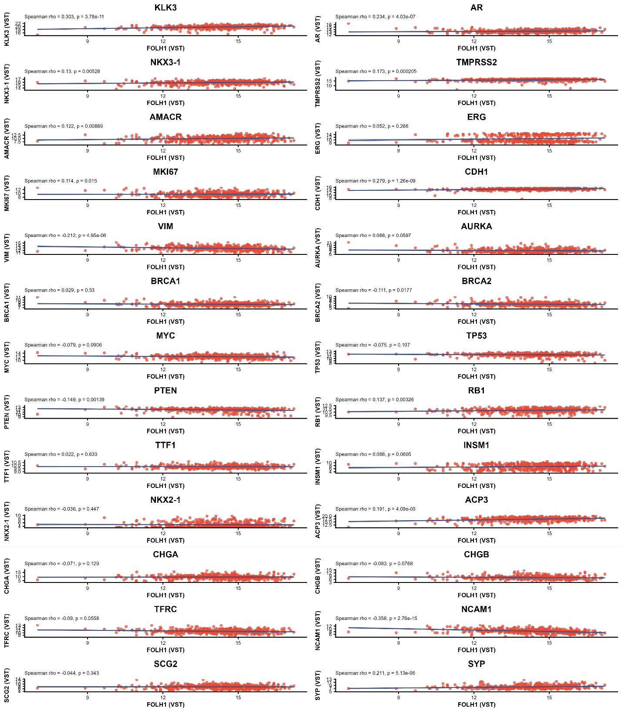

DFS Survival analysis for biomarkers
Out of all the above listed biomarkers, PAP (ACP3), AURKA, CDH1, KLK3, MKI67, NCAM1 all showed statistically significant distinct separation between their high and low expression sample groups in the survival analysis, while NKX-3 and PTEN also showed close to significant separation.
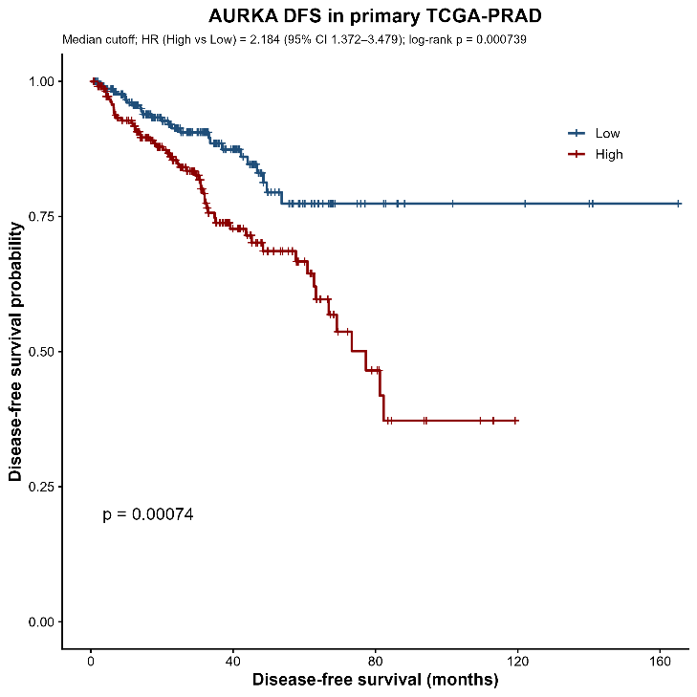
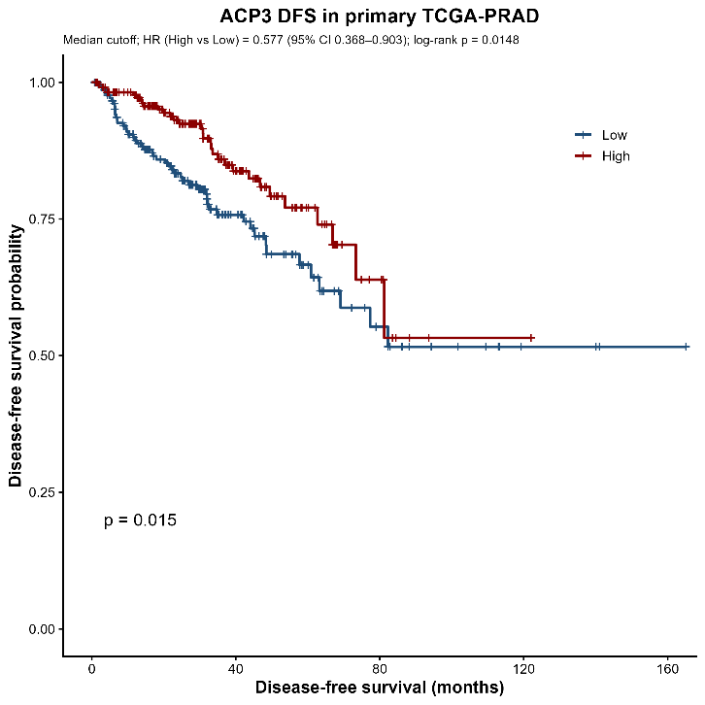
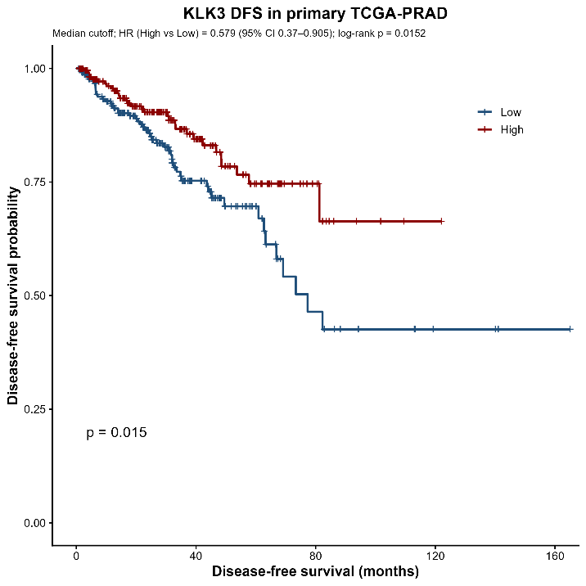
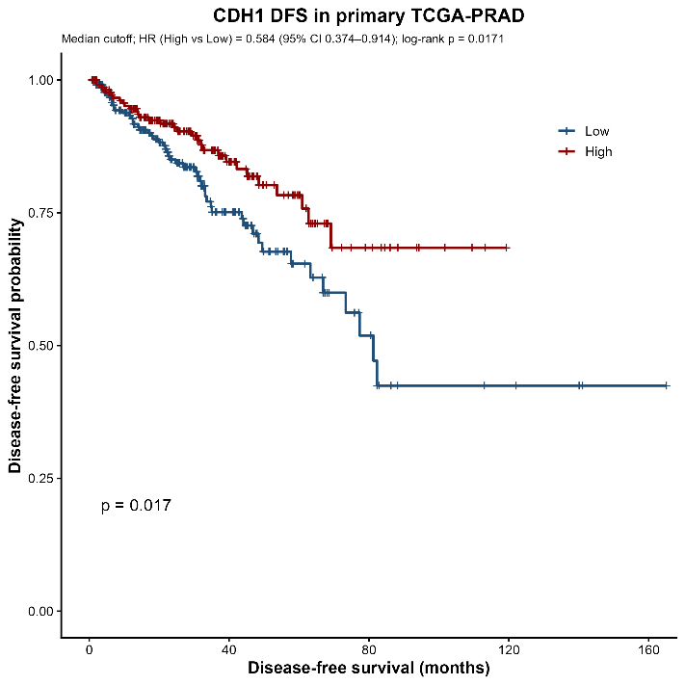
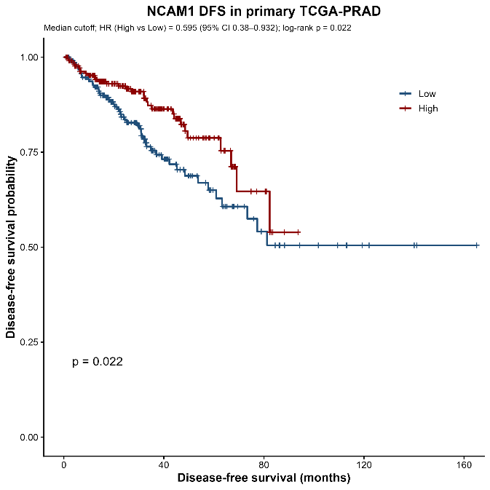
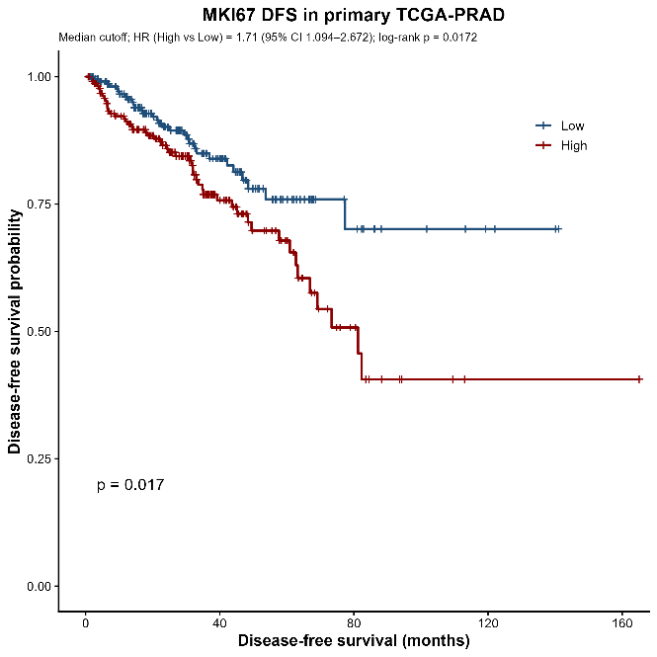

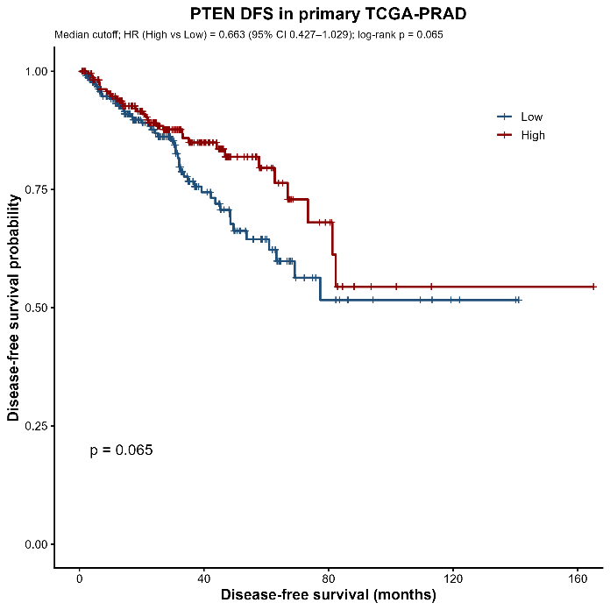
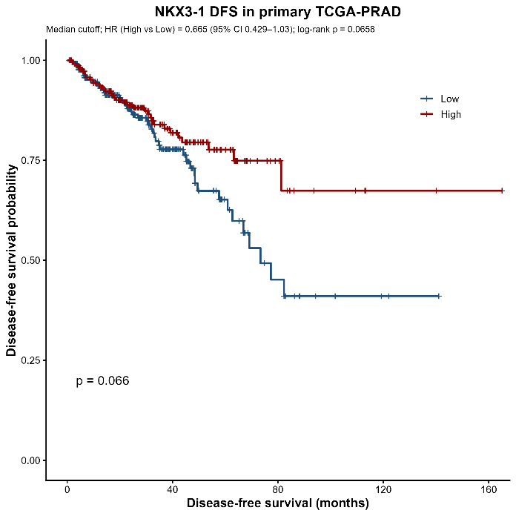

Comparison of FOLH1 with Known Prostate Cancer Biomarkers (metastatic samples)
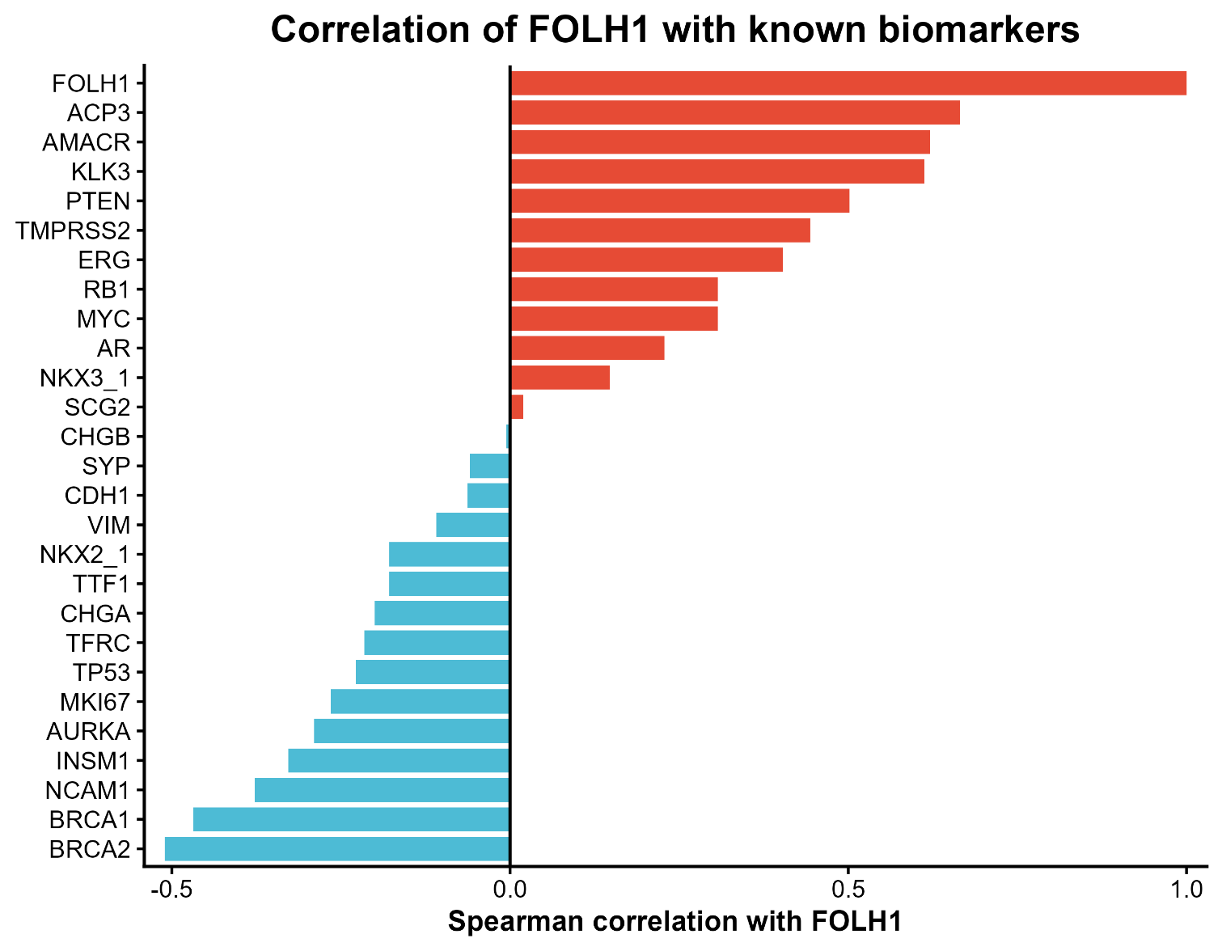
The same biomarkers were compared with FOLH1 from the MSKCC2010 cohort in metastatic samples. Out of a total of 236 samples, 37 were metastatic samples of which only 19 showed gene expressions. The analysis was done based on these 19 samples.

Gene | Protein marker | Rho | P value
ACP3 | PAP | 0.664912 | 0.002464
AMACR |  | 0.621053 | 0.00547
KLK3 |  | 0.612281 | 0.006332
PTEN |  | 0.501754 | 0.030298
TMPRSS2 |  | 0.44386 | 0.058489
ERG |  | 0.403509 | 0.08782
MYC |  | 0.307018 | 0.200588
RB1 |  | 0.307018 | 0.200588
AR |  | 0.22807 | 0.346125
NKX3_1 |  | 0.147368 | 0.545793
SCG2 | Secretogranin II | 0.019298 | 0.93968
CHGB | Chromogranin B | -0.00526 | 0.985626
SYP | Synaptophysin | -0.05965 | 0.809119
CDH1 |  | -0.06316 | 0.797947
VIM |  | -0.10877 | 0.656954
TTF1 |  | -0.17895 | 0.461923
NKX2_1 |  | -0.17895 | 0.461923
CHGA | Chromogranin A | -0.2 | 0.41001
TFRC | CD71 | -0.21579 | 0.373308
TP53 |  | -0.22807 | 0.346125
MKI67 |  | -0.26491 | 0.271901
AURKA |  | -0.28947 | 0.228565
INSM1 |  | -0.32807 | 0.170212
NCAM1 | CD56 | -0.37719 | 0.112153
BRCA1 |  | -0.46842 | 0.044756
BRCA2 |  | -0.51053 | 0.027192

DFS Survival analysis for biomarkers for metastatic samples
The biomarkers that showed significant or close to significant differences in DFS survival analysis once grouped based on median expression level are below.
